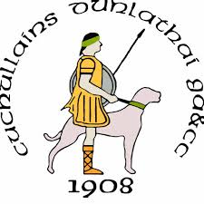 |  |  |  | Leo Neenan  Optimal BioMechanics
Dunloy Cuchullains
Athlete Development 6 - 16-years
Optimal BioMechanics

Template for Athlete Development (AD)
The goal of the following document is to lay out a template for introducing 6 – 16 year old’s to the development skills for sports participation through their formative years
While the long-term athletic development (LTAD)may be geared towards the skills of both hurling and football this template aims to help develop the basic movement skills that underlie all sports specific skills.
The desired outcome from this program is to help participants to move better with focus on running, jumping, balance and co-ordination.
Every Child is an Athlete
Sincerely, Leo Neenan
19-21 Ormeau Ave.
Belfast BT2 8HD

078681454222

 | info@optimal.bio
 | https://optimal.bio/

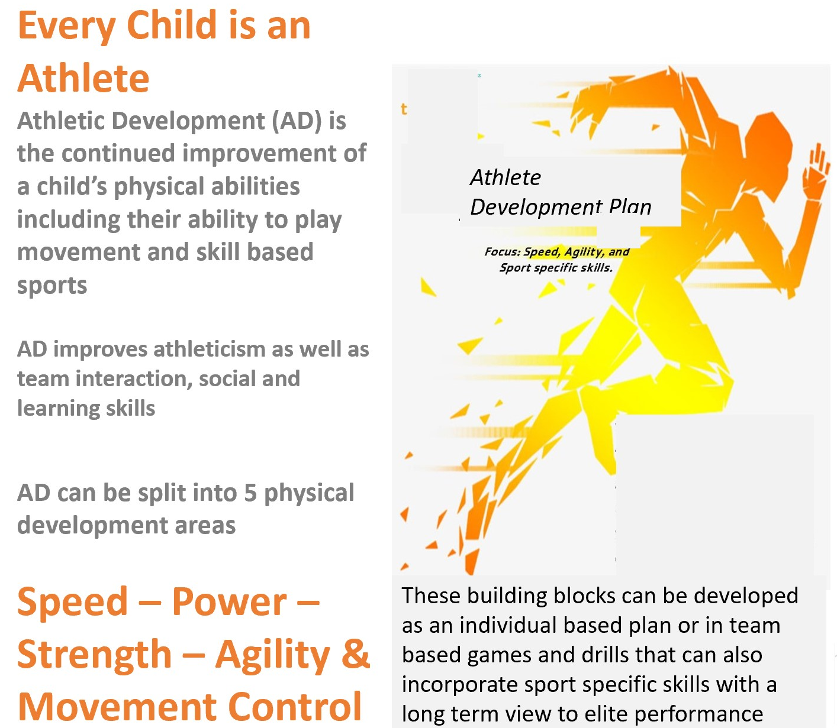
Based on the 5 building blocks the Athlete Development Plan is structured to develop each area individually
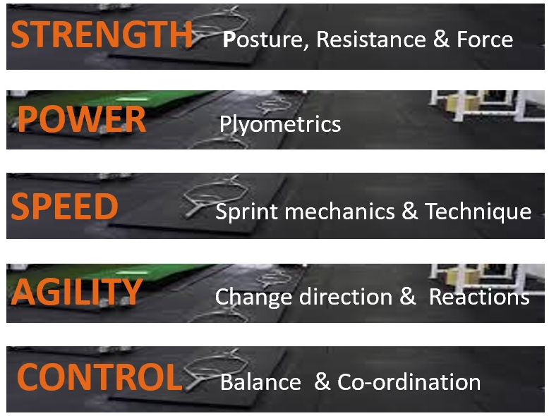 Consists of Functional exercises, conventional gym exercises, body weight exercises
Consists of jumping and landing, acceleration and deceleration drills
Consists of Sprint coaching, positioning and foot work for
Consists of Turning, spatial awareness games and multi sports drills
Consists of mobility, proprioception, floor based athleticism and movement skills
As training competence improves multi-faceted drills can be implemented which allows for development of a combination of these building blocks in 1 drill

WEEK 1.
Laying the ground work - Do 3 times per week
Control | The Bear Series  PLAY VIDEO  - 1 arm  - 1 arm & 1 Leg  - 1 arm, 1 leg & rotate  Target Reps: 5 of each
Agility | Turning Jump PLAY VIDEO  - Left and Right Measure your Jump  Target Reps: 3 x 2 Aim: + 10%
Speed | Knee Up Sprint Start PLAY VIDEO  Target Reps 2 x 4 each side
Power | ½ Kneeling Box Jump PLAY VIDEO  Target 2 x 4 each side
Strength | Plank Squat PLAY VIDEO  Target 2 x 4 each side

